**APPLICATION TUTORIAL FOR SEMESTRAL MOBILITIES**

1. Go to <https://stag-avu.zcu.cz/portal>
2. 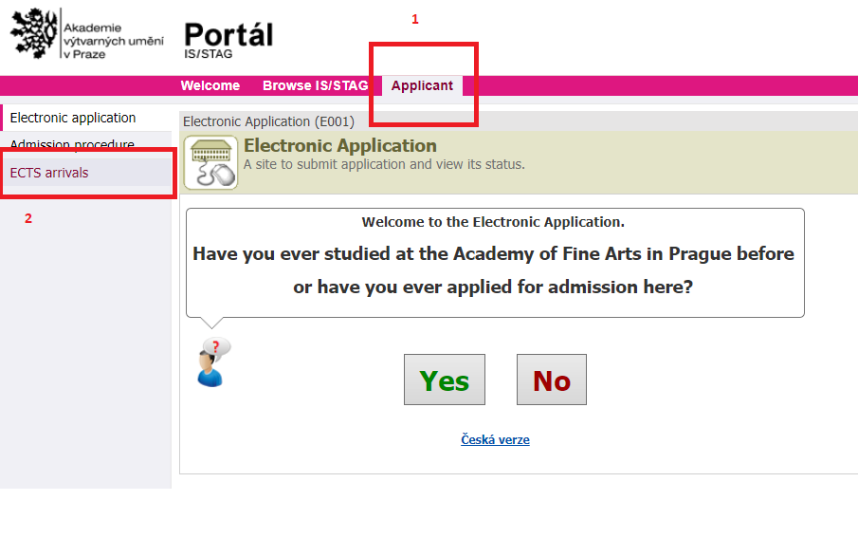Click on APPLICANT/ECTS ARRIVALS and answer the Yes/No question.
3. 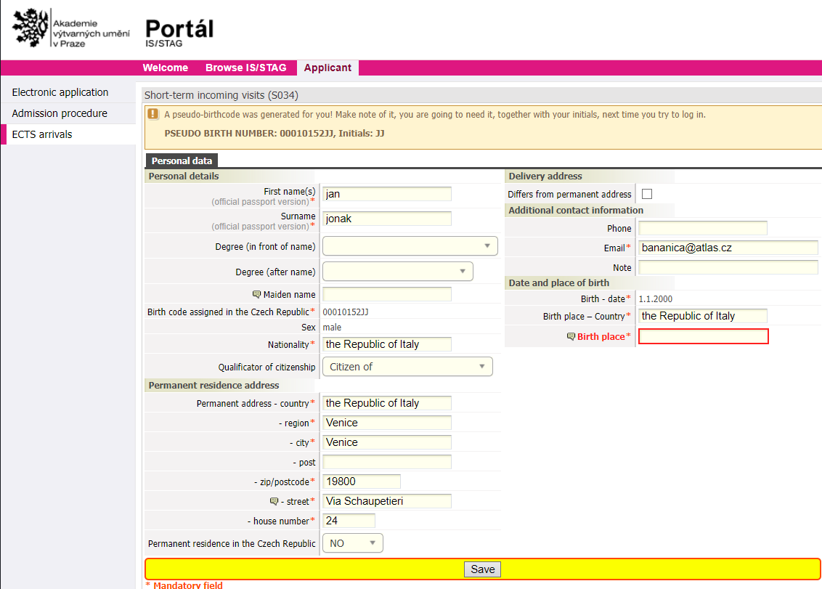The system will use your EMAIL ADDRESS for you to log in.

Fill in your personal data and SAVE

1. CLICK ON “Incoming study visit”

>Enter ARRIVAL/DEPARTURE DATES and SEMESTER:

Fall/Winter semester > early October – late January

Spring/Summer semester > mid February – mid June

>Select the DEPARTMENT, the Studio of your preferred specialization. Choose from the [List of studios](https://www.avu.cz/en/study/cG9zdDoyNTM5/studios) and select accordingly

Studio is the only obligatory component of your mobility. It equals 20 ECTS

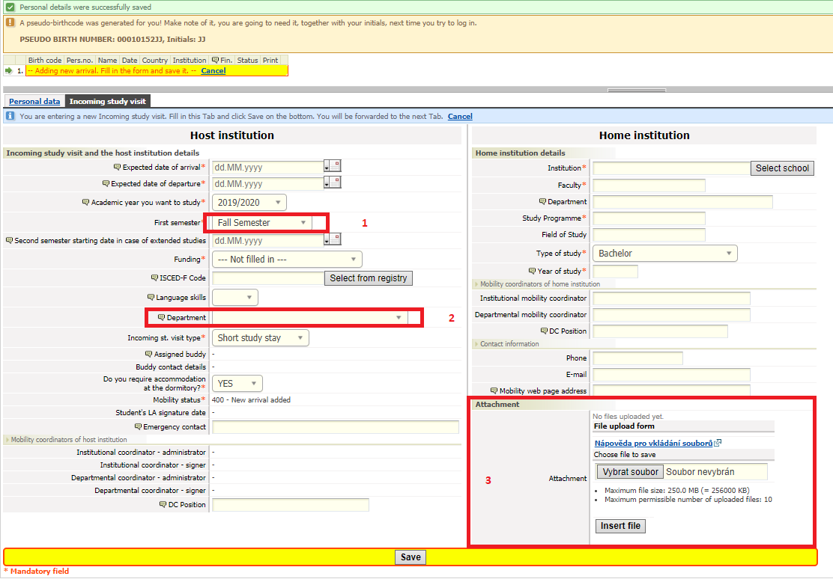

>DORMITORY: NO, AVU doesn’t have dormitories, students find accommodation independently

>For MOBILITY STATUS select 400

>Fill in your INSTITUTION details

>Upload the ATTACHMENTS

*Please, put your **LAST NAME** on each one of the attachments to ease the application process

1) photo (**NOT** your passport)* that will be used for AVU student card

2) portfolio (not larger than 5 MB)*

3) CV*

4) motivation letter*

**Don’t forget to SAVE!**

**\*Please note that by SAVING, the data is sent and submitted to AVU.**

**You can edit your application until the date of submission deadline (30 April/ 30 October)**

1. STUDIO WORK and COURSES*

**\*the course offer is updated every summer. For 1st semester it is not possible to enter courses before September.**

Once the Course Offer is active:

Go to bookmark **COURSES**, For FACULTY select **“AVU-null”** then **“Search courses”**

Select the STUDIO that you have applied for (20ECTS)

Enter COURSES:

Contemporary Art (1st semester) (2nd semester) (4 ECTS)

Computer Graphics (3ECTS)

Figural Drawing (3 ECTS)

Graphic (Printmaking) Techniques (3 ECTS)

Czech Language (beginners) (1 ECTS)

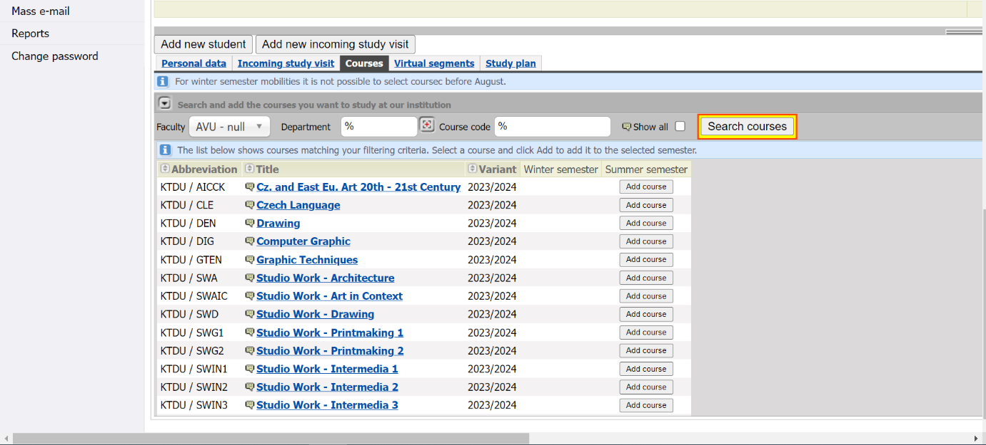

1. Your courses confirmed by AVU coordinator later appear in your LA (Learning Agreement).

Now your application is complete!

If you have any questions let me know, or if relevant send a screenshot:-)

*Once you create your application, an email confirmation is sent to your personal inbox

*The acceptance/rejection will be confirmed to you by early June for FALL/WINTER semester, and by early December for SPRING/SUMMER semester